|  |
| --- |
| **E-commerce Website for Sporty Shoes** |
| (Project ScreenShots) |

**Version History:**

|  |  |
| --- | --- |
| Author | Tata Sai Vineeth |
| Purpose | Screenshots of the application |
| Date | Nov 11,2021 |
| Version | 1.0 |

Contents

1. Admin Login: 3

2. Admin Home Page: 4

3. Admin ChangePassword: 6

4. User list: 7

5. Product list: 8

6. User Registration: 9

7. User Dashboard: 10

8. Product List: 11

9. Ordering Product: 11

10.ReLogin page: 12

# Admin Login:

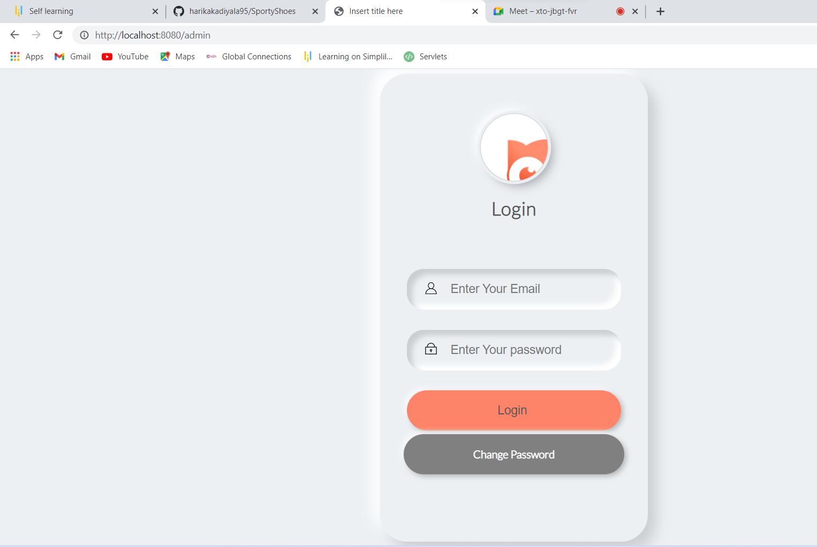

# Admin Home Page:

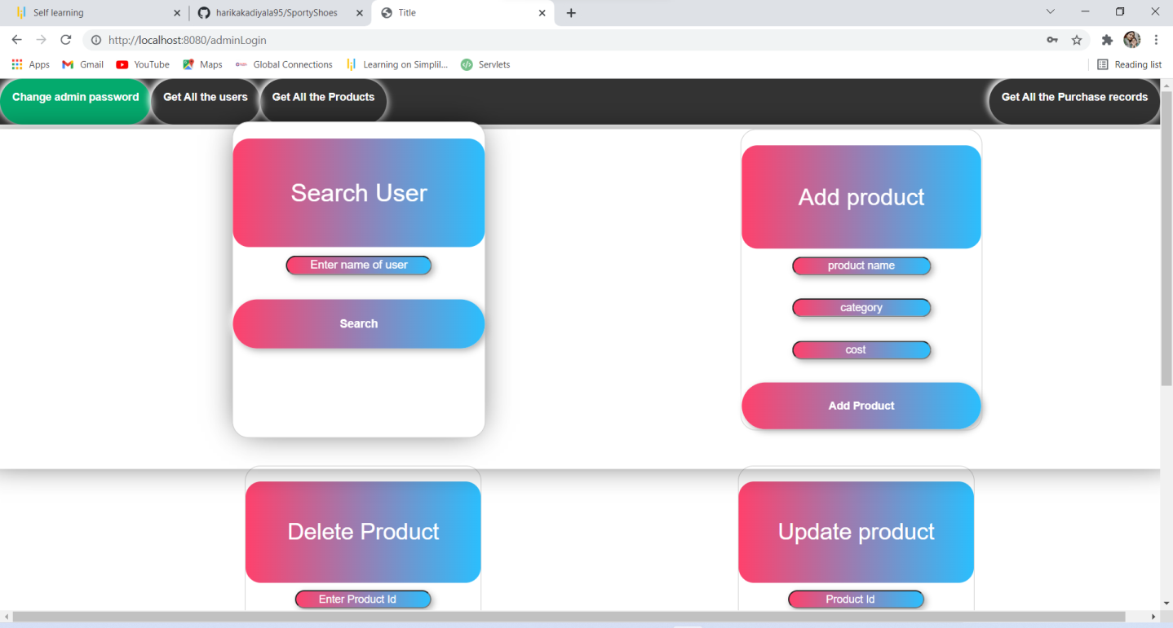

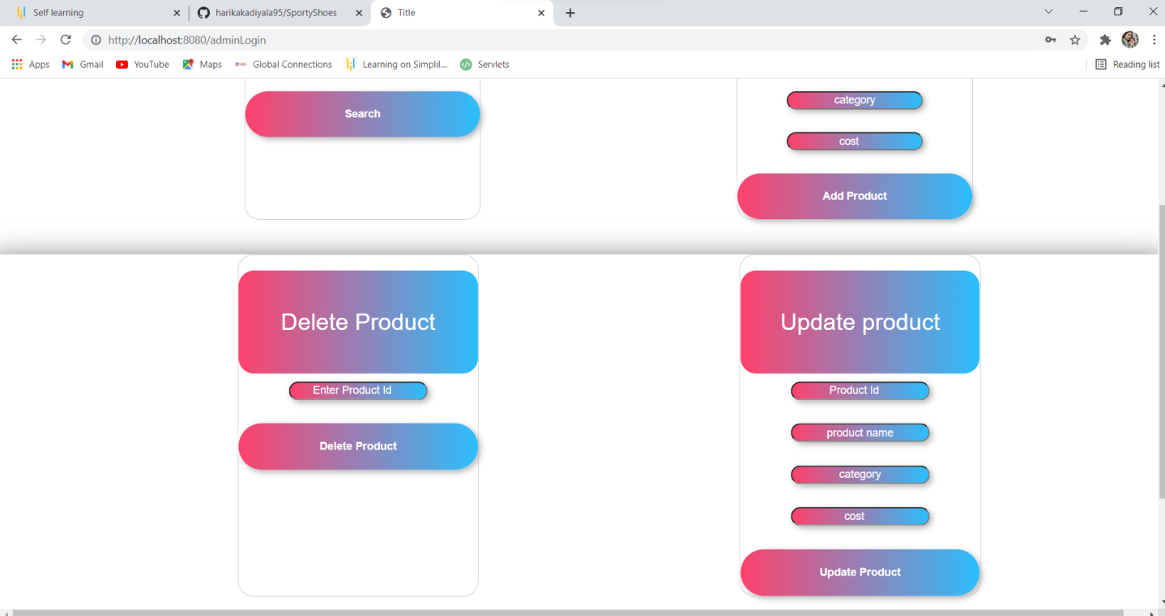

# Admin ChangePassword:

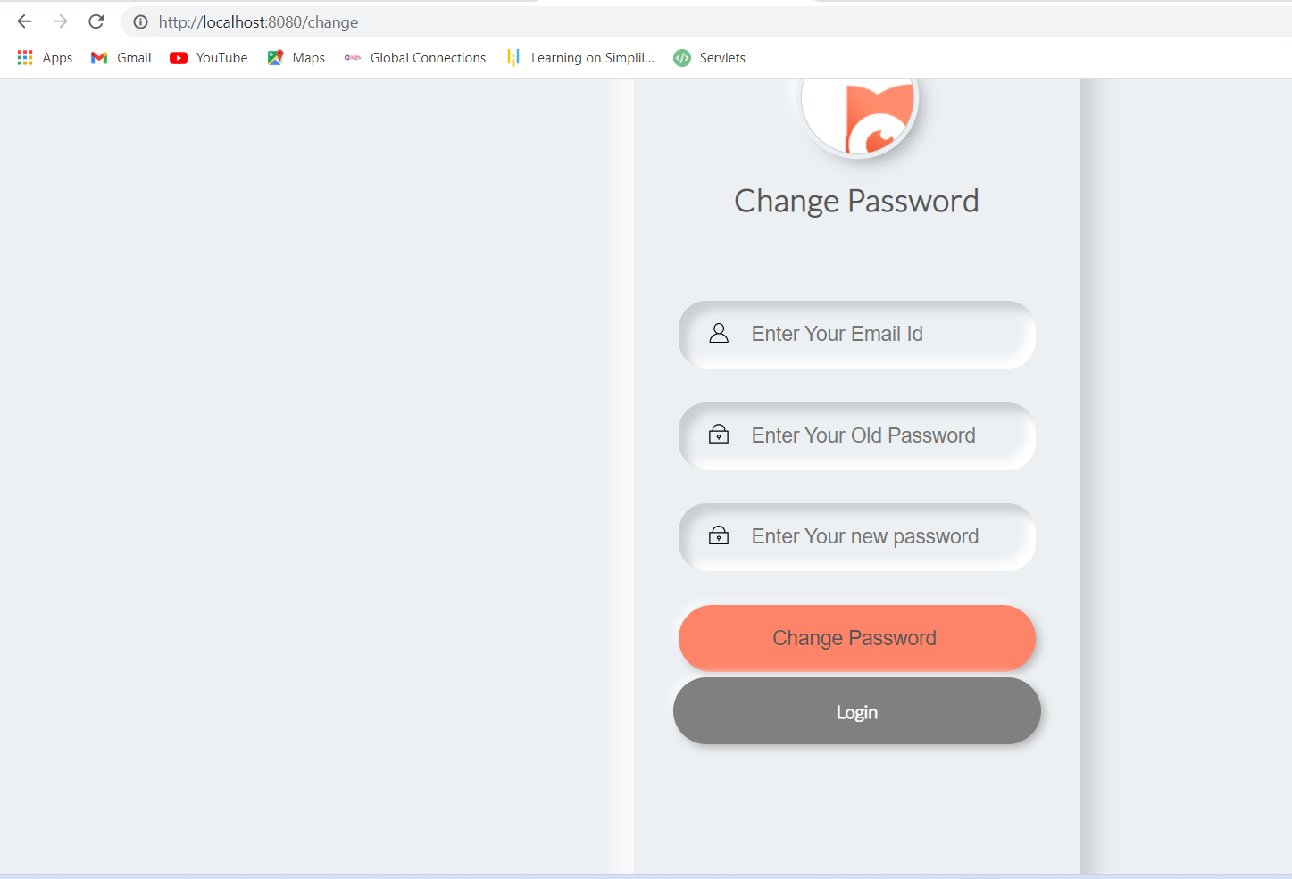

# User list:

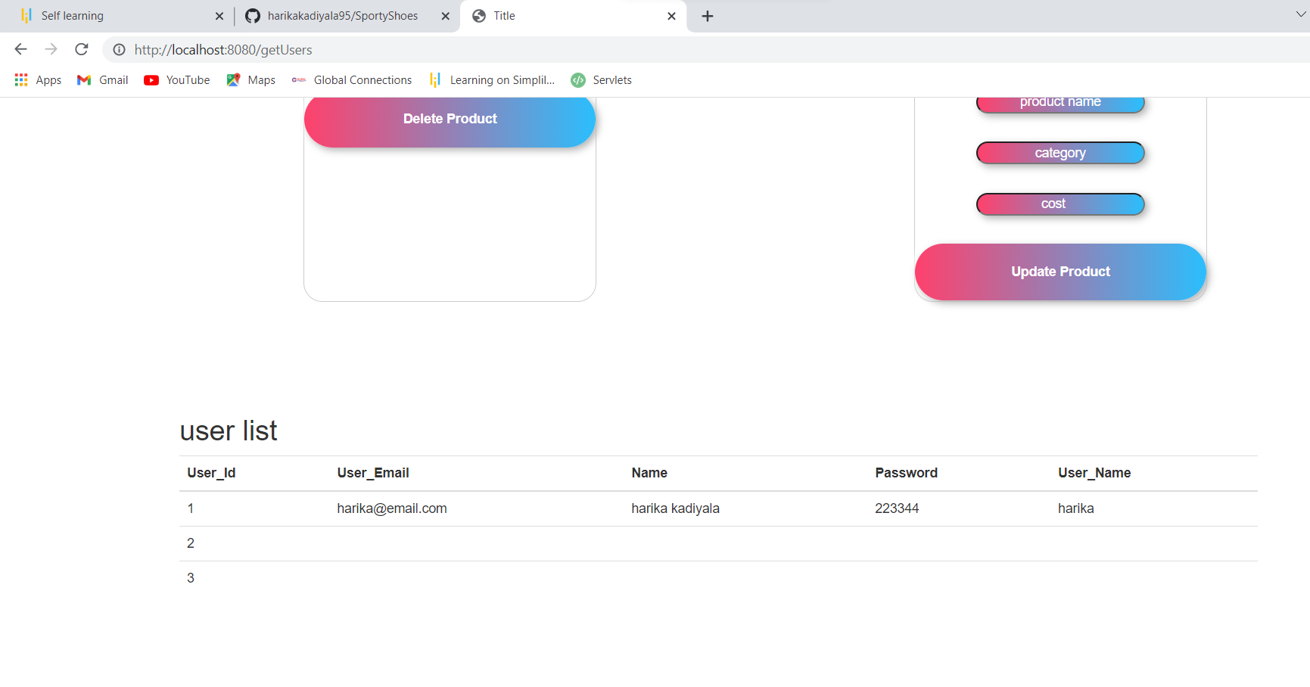

# Product list:

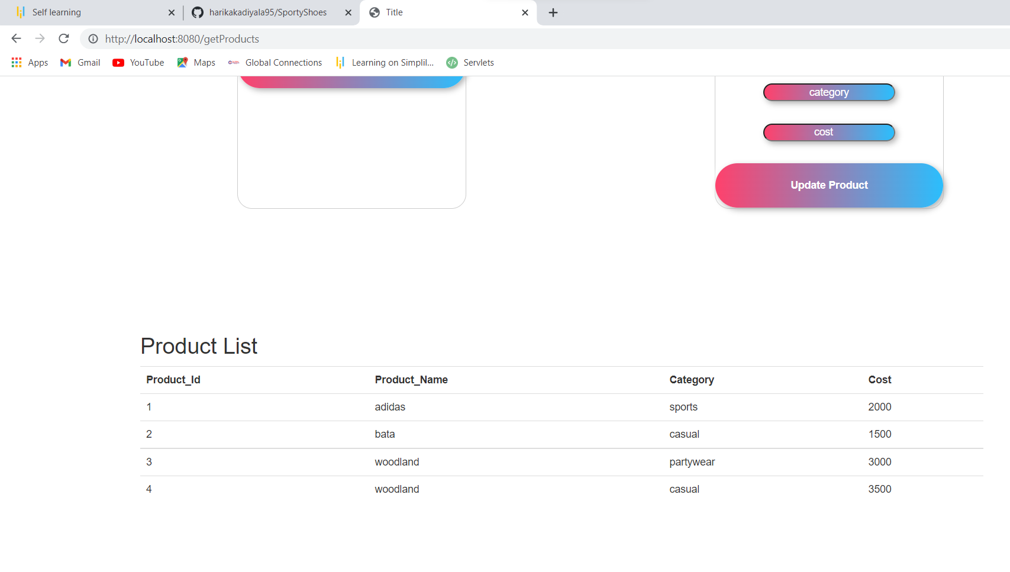

# User Registration:

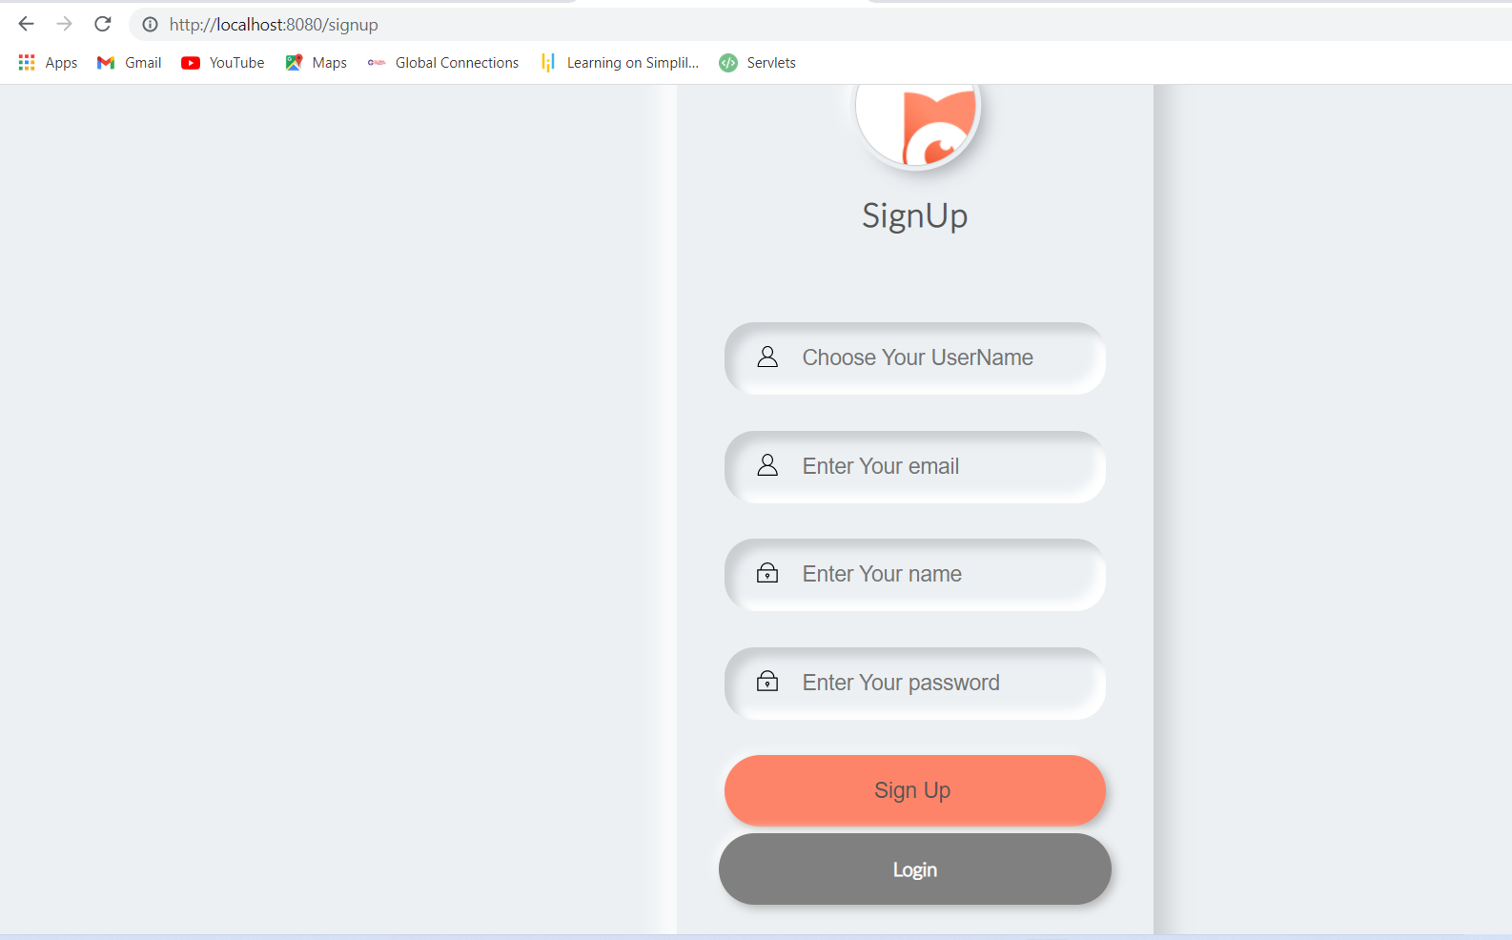

# User Dashboard:

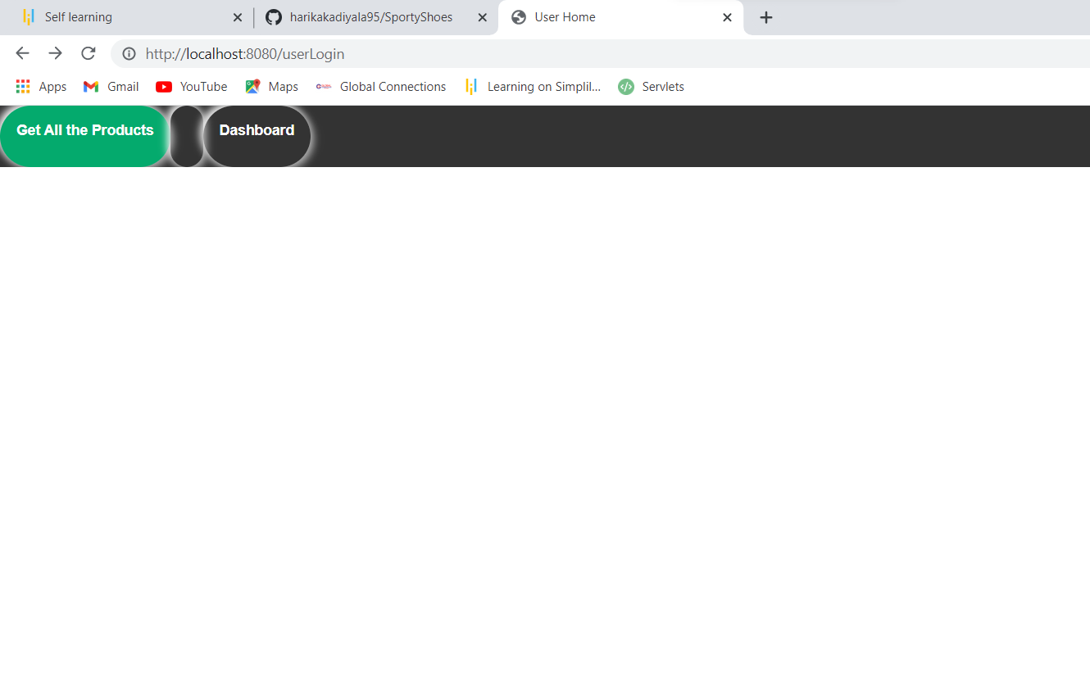

# Product List:

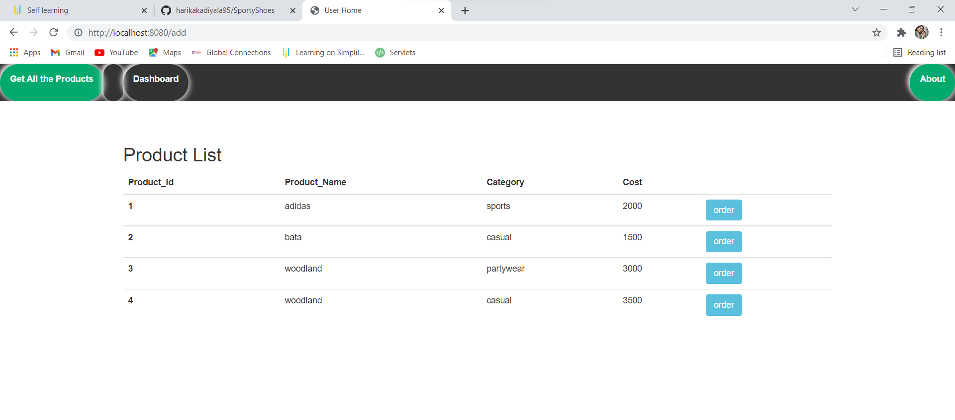

# Ordering Product:

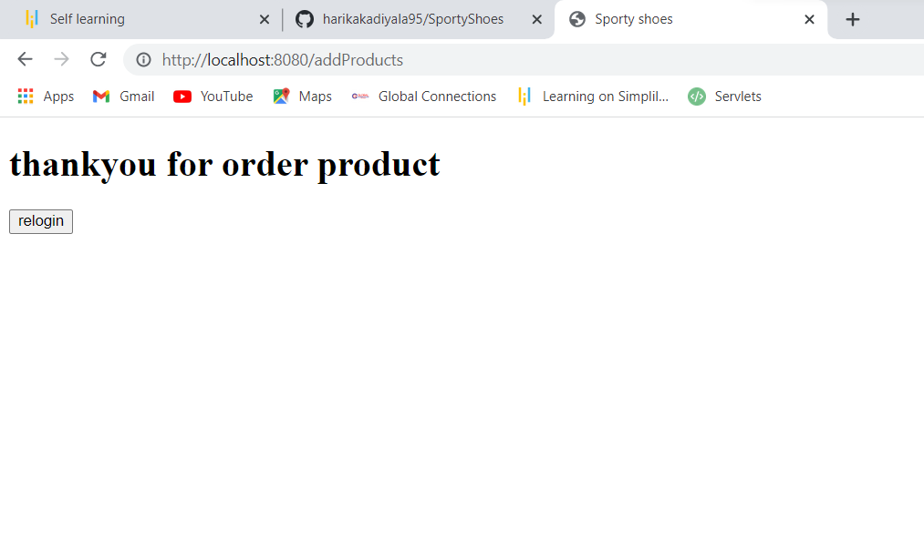

# ReLogin page:

# 

**Thank You,**

**TATA SAI VINEETH,**

**Simplilearn.**